skills matrix template

Skills Matrix Template

1. Employee Information
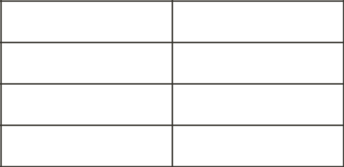

Name

Position

Department

Date

2. Skill Categories

List main skill categories relevant to your organization (e.g., Technical Skills, Soft Skills, Leadership Skills)

Technical Skills

Soft Skills

Leadership Skills

3. Skill Levels

Define skill levels (e.g., 1-5 scale or Beginner/Intermediate/Advanced)

1 | Beginner
2 | Basic
3 | Intermediate
4 | Advanced
5 | Expert

4. Skills Matrix

Skill

Current Level

Target Level

Comments

skills matrix template 1

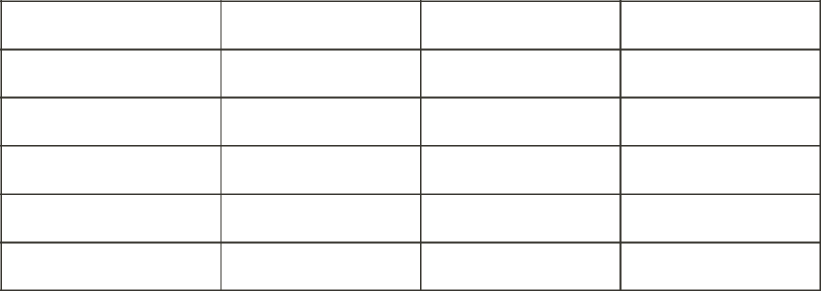
Technical Skill 1

Technical Skill 2

Soft Skill 1

Soft Skill 2

Leadership Skill 1

Leadership Skill 2

5. Development Plan
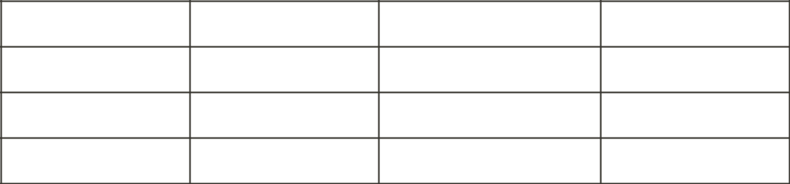

Skill to Improve Action Plan

Resources Needed Timeline

6. Review and Approval
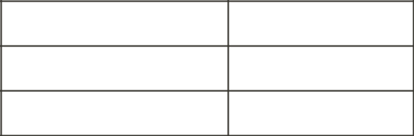

Employee Signature

Manager Signature

Date

Note: This template can be customized to fit the specific needs of your organization. Add or remove sections as necessary.

skills matrix template 2

