RACI template

Project: [Project Name]

Last Updated: @September 15, 2024
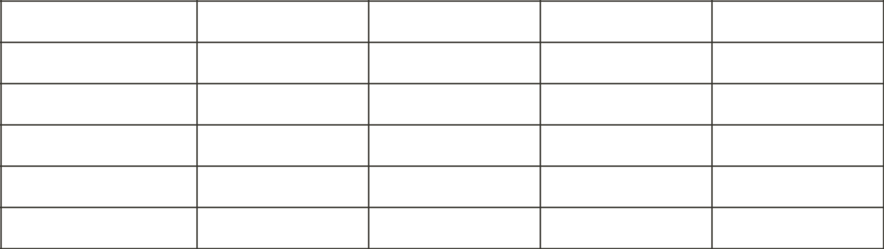

Task / Deliverable Responsible | Accountable | Consulted | Informed

[Task 1]

[Task 2]

[Task 3]

[Task 4]

[Task 5]

Legend:

R - Responsible: Who is responsible for performing the task?

A - Accountable: Who is accountable for the task's completion?

C - Consulted: Who should be consulted before a decision or action is taken?

I - Informed: Who should be informed about the task's progress or decisions?

Instructions:

- Replace [Project Name] with your specific project title.

- List all major tasks or deliverables in the first column.

- For each task, assign roles \R, A, C, I\ to team members or departments.

- Ensure there is only one 'A' \Accountable) person per task.

- Update the template regularly as the project progresses.

Remember: A well-defined RACI matrix helps clarify roles and responsibilities, improving project efficiency and communication.

RACI template 1

